HSC Core 1: Health Priorities in Australia (COVID-19 Case Study)

Syllabus Content | Revision Questions | Internet Links
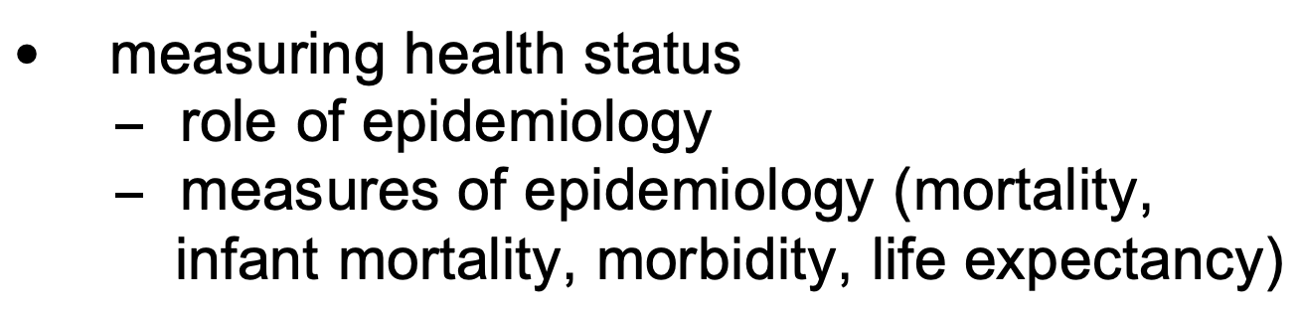 | - Define mortality and research current mortality statistics related to COVID-19. How does NSW mortality rates compare to other states of Australia? How do Australia’s mortality rates compare to the rest of the world?  - Define morbidity and research current morbidity statistics related to COVID-19. How does NSW morbidity rates compare to other states of Australia? How do Australia’s morbidity rates compare to the rest of the world?  - What can epidemiology tell us about the impact of COVID-19?  - Who would use the measures of epidemiology during the pandemic and for what purpose? (Provide an example)  - Do the measures of epidemiology measure everything about health status? What are the benefits and limitations of using epidemiological data during the pandemic? | World view - https://coronavirus.jhu.edu/map.html  Australia - https://www.health.gov.au/news/health-alerts/novel-coronavirus-2019-ncov-health-alert/coronavirus-covid-19-case-numbers-and-statistics  NSW - https://www.health.nsw.gov.au/Infectious/covid-19/Pages/stats-nsw.aspx
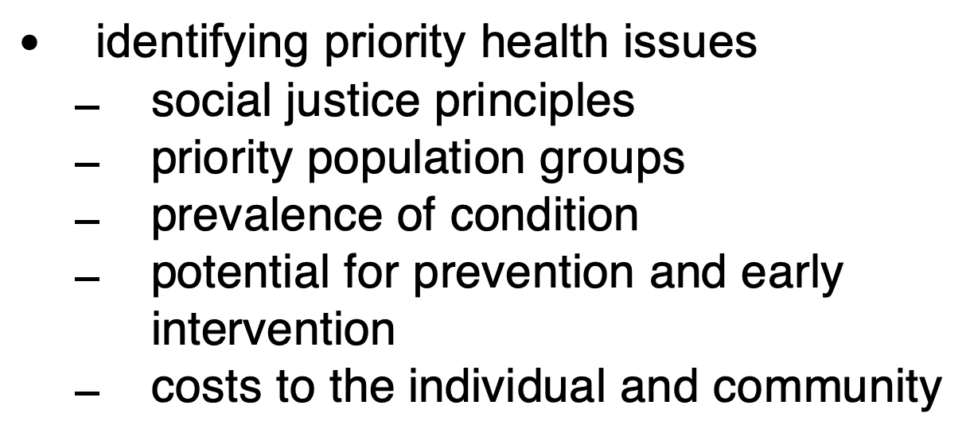 | - Why would we currently identify COVID-19 as a priority issue for Australia’s health?  - Outline the purpose of the social justice principles? What role do the principles of social justice play when dealing with COVID-19?  - Diversity:  - Equity:  - Supportive Environment:  3) Prevalence of the condition: During the most recent lockdown in NSW, how did NSW Health identify what areas of NSW and Sydney to “lock down”? Discuss why some metropolitan (Greater Sydney) and regional areas were given different restrictions? How could this data assist NSW Health with facilitating more COVID-19 testing centres?  4) Priority population groups: How does NSW Health determine priority population groups in regards to COVID testing and vaccination.  - Vaccination process: Argue who should be vaccinated first and why?Why were the elderly in aged care homes the first groups vaccinated? Analyse how NSW Health prioritises who gets vaccinated in what order during the current lockdown.  - Contact Tracers: In regards to priority population groups, what impact can contract tracers have to reduce the spread of COVID-19.  5) Evaluate whether the potential for prevention and early intervention (testing and vaccination) outweighs the “herd immunity” theory?  6) Cost to the individual and community  - Discuss the impact to the individuals and the community if they are thinking of or have had a COVID test and are awaiting their test results.  - Outline the costs to the community in relation to the widespread COVID testing that is currently affecting Greater Sydney and some areas of regional NSW. | ABS Data - https://www.abs.gov.au/websitedbs/d3310114.nsf/home/interactive+maps  ABS Data (One year of COVID-19: Aussie jobs, business and the economy)  - https://www.abs.gov.au/articles/one-year-covid-19-aussie-jobs-business-and-economy#:~:text=72%25%20of%20businesses%20had%20less,vacancies%2043%25%20below%20February%20figures.
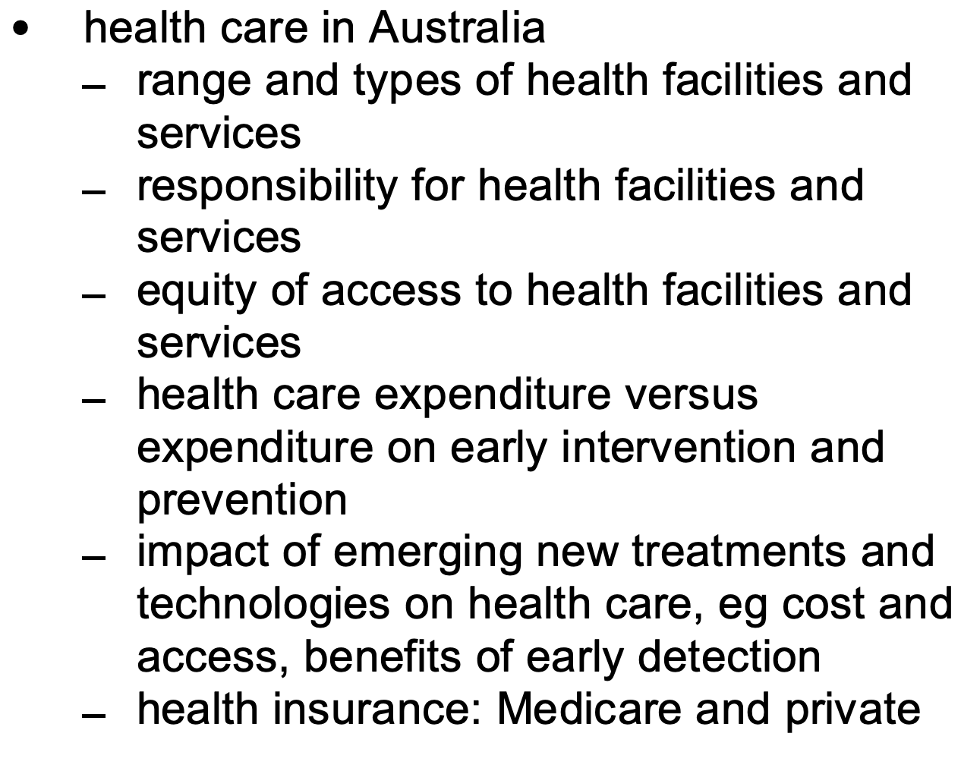 | - List the range and types of healthcare facilities and services accessed during the COVID19 pandemic.  - Based on the list above, who is responsible for the health facilities and services?  - Discuss whether there is equity of access to health facilities and services. (Consider vaccinations and testing.)  - Research how much the Government spent on the following COVID-19 related services?  - COVID19 tests? E.g Pathology costs, number of people involved in the process from start to finish.  - Vaccination research.  - Securing vaccinations.  - Medical treatment/hospital admissions.  - Discuss the benefits of having a regular COVID test if you live in a hotspot area.  - Argue how much responsibility should the community assume for individual health problems? Describe actions that individuals and the community can take to reduce the risks of COVID-19?  - Describe how Medicare can be used to assist with COVID-19 related issues? What impact could COVID-19 have on our public health care system? | AIHW - COVID 19 https://www.aihw.gov.au/covid-19  NSW Government - https://www.nsw.gov.au/covid-19
-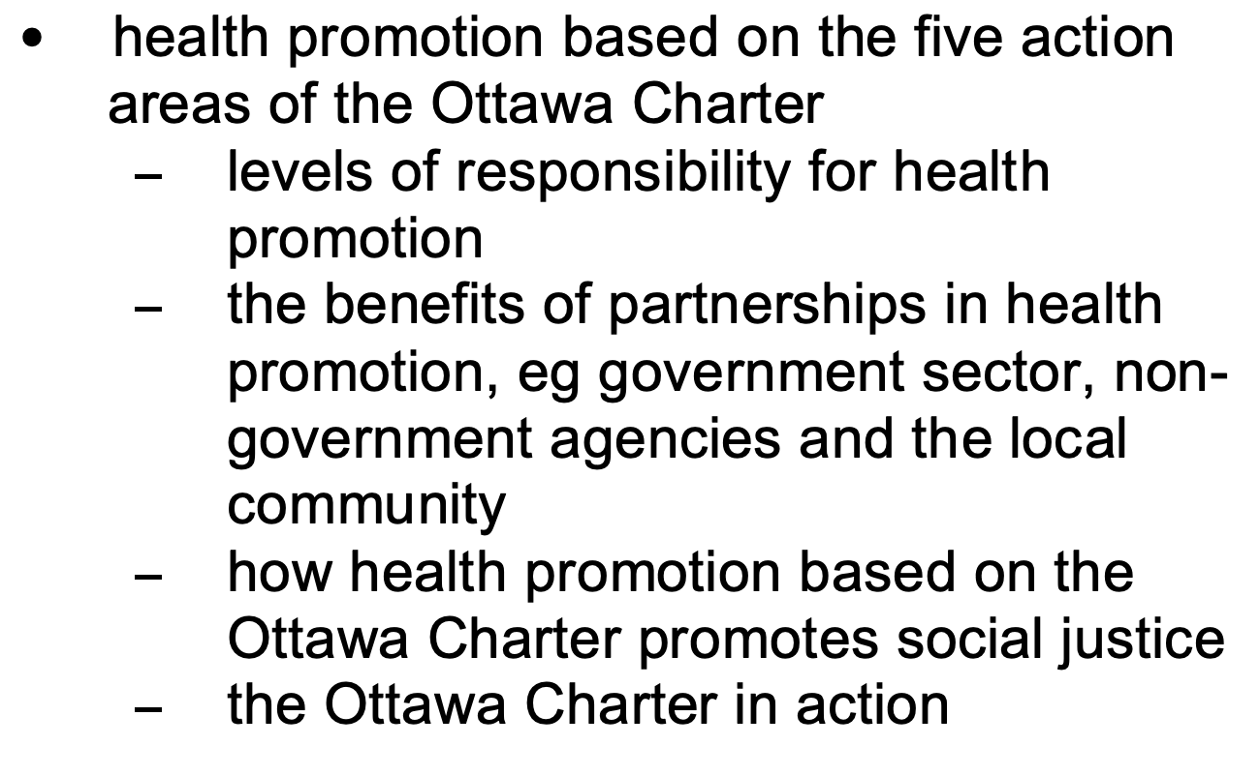 | Levels of responsibility for health promotion:  - Research what each level of government (Federal/State/Local) is responsible for regarding the COVID19 pandemic. Provide specific examples in each level of government.  - Investigate the responsibilities of individuals, communities and governments during the current COVID-19 pandemic. Use the action areas of the Ottawa Charter to create a table and list where each responsibility would fit specific to health promotion.  - Discuss how individuals, communities and governments have worked in partnerships during the COVID-19 pandemic. Illustrate your response with a variety of examples.  The benefits of partnerships in health promotion:  - Argue the benefits of health promotion around COVID being based on individuals, communities and governments working in partnership. Where are we seeing these partnerships occurring? Where do we see opportunities for future partnerships?  The Ottawa Charter in action:  - What is the purpose of the Ottawa Charter?  Developing Personal Skills:  - Definition:  - List ways that NSW residents can currently access information about COVID 19.  - Click the image below, discuss how the health promotion initiative develops personal skills throughout the COVID-19 pandemic.  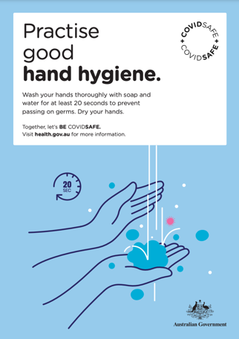  - Using the link attached, collate a bank of examples of COVID-19 health promotion initiatives that the Australian Government has used and outline how they assist develop personal skills.  - Using the following link discuss the effectiveness of this resource for ALL Australians in understanding COVID 19.  Strengthening Community Action:  - Definition:  - List three things that are currently evident in your shopping areas/hospitality venues that are assisting in the fight against COVID 19 . Discuss how this links to the OC Action Area - Strengthening Community Action.  - What strategies have already been implemented in your school to reduce the risk of the virus spreading. What action steps can schools instigate and take ownership of in the prevention of spreading COVID-19? NESA - Covid -19 Advice  Create a Supportive Environment:  - Definition:  - Using the attached link outline how the wearing of masks assists to create a supportive environment. Ensure that you use a variety of examples within your response.  - Discuss how social distancing can continue to create a supportive environment.  - Examine why it is important that COVID-19 pop up testing facilities have been introduced into hotspot areas.  - How does the use of the NSW Services QR code reflect the OC Action Area - creating a supportive environment.  - Discuss the importance of having an Auslan Interpreter present at the NSW Government’s daily press conferences (Also link to Developing Personal Skills).  Building Healthy Public Policy:  - Definition:  - Using the attached link critically analyse the importance of how the NSW Governments “Stay At Home Orders” and other laws and legislation can have an impact on the current COVID-19 outbreak within the Greater Sydney Community. Ensure that you use a variety of examples within your response.  Reorient Health Services:  - Definition:  - Discuss the importance of having a variety of testing facilities for COVID-19.  - Research and list the places where people can currently get a COVID 19 vaccination and where they may be able to get it in the future. Explain the benefits of having a variety of options for where people can get the COVID 19 vaccine. | Federal - https://www.health.gov.au/news/health-alerts/novel-coronavirus-2019-ncov-health-alert/government-response-to-the-covid-19-outbreak  https://www.australia.gov.au/

